Apple Pay on the Web
Integration for Merchants using Gateway Credentials

When embedding an Apple Pay payment button on your own web site, you can use the Gateway’s Apple Pay Payment Processing and Merchant Identity certificates, along with a unique Apple Pay Merchant Identifier registered for you by the Gateway.
This allows you to take Apple Pay payments on your web site as easily as taking them on the Gateway’s Hosted Payment Page. You are not required to have your own Apple Pay Developer Account, as you do not need to setup your own Apple Pay Merchant Identifier and associated Payment Processing and Merchant Identity certificates.
The Apple Pay browser integration steps are the same as when using your own Apple Pay Merchant Identifier and associated certificates, however instead of your web server sending a Merchant validation request to the Apple Pay server, it is sends one to the Gateway, which will add the credentials before passing the request on to Apple Pay.

The ability to use these Gateway credentials is only available for Apple Pay on the Web, that is embedding an Apple Pay button in a web page for use when using the Apple Safari web browser. They cannot be used when embedding an Apple Pay payment button in a native iOS application.

Configuration
To use the Gateway’s Apple Pay credentials, you must first let the Gateway register your web store’s domain name with Apple Pay. This is the domain of your store’s web page on which you wish to embed the Apple Pay payment button. You can register multiple domains if required.
To do this please add your store’s domain, or domains, to the list of custom domain names available in MMS under Preferences -> Digital Wallets
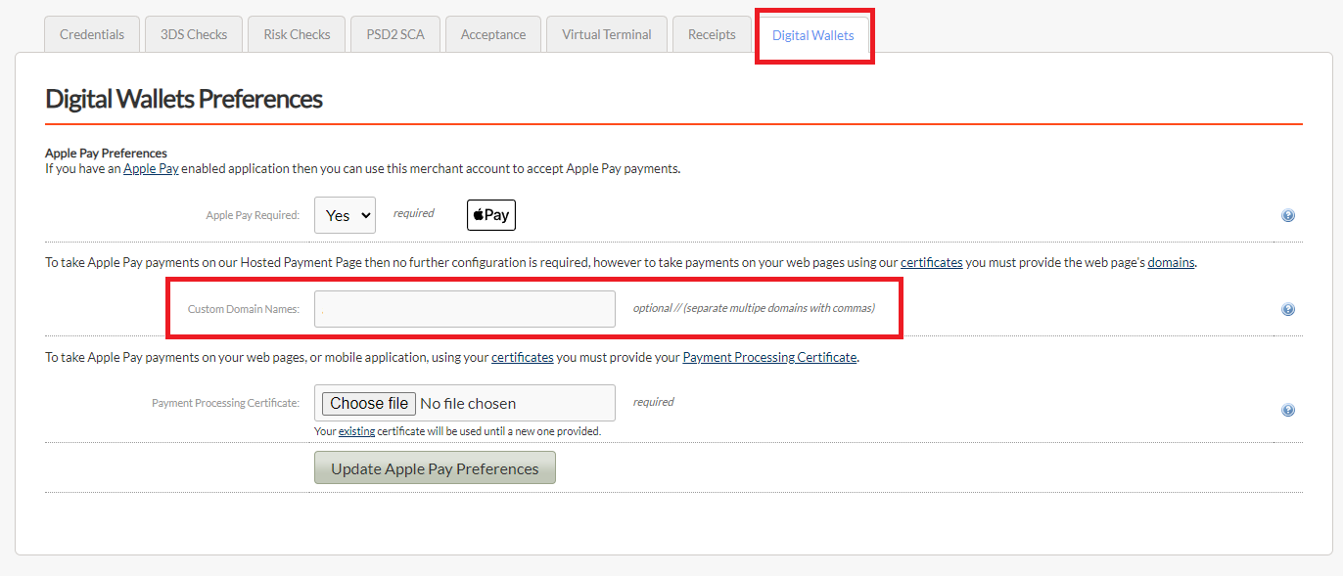

When you have entered your store’s domain name and pressed enter, a pop-up window will alert you that you have made a change to the Apple Pay Custom Domain Names list and will need to download a Domain Verification File. Please read the instructions on the pop-up window.
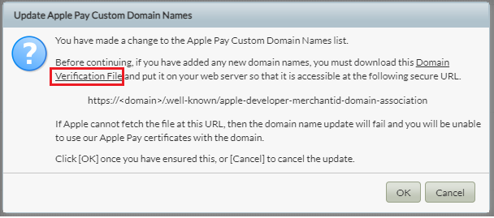
The Domain Verification File is linked for downloading in the help pop up. Click the link to download it and then place it on your webserver in the .well-known directory.
Apple must be able to download the file from your store’s web server at the location shown or domain registration will fail. Please ensure that you do not click [OK] until the file is available. Apple will only support secure HTTPS URLs; you cannot serve the file from a HTTP URL.
Integration
In your Apple Pay on the Web JavaScript integration code, as part of your Apple Pay session object’s onvalidatemerchant event handler, you would send a message to your web server to ask it to request a payment session from the Apple Pay server. To use the Gateway’s credentials, instead of your server requesting this payment session from the Apple Pay server, you should send a Merchant validation request to the Gateway, which will then forward the request to the Apple Pay server on your behalf.
The Apple Pay Merchant validation request sent to the Gateway must contain the following fields:
- merchantID – this is the Gateway Merchant Account ID you are using to process the Apple Pay transactions.
- process – this must be the value ‘applepay.validateMerchant’ and is used to indicate to the Gateway that this is an Apple Pay Merchant validation request.
- validationURL – this is Apple Pay validation URL taken from the validationURL property of the ApplePayValidateMerchantEvent object received by the onvalidatemerchant event handler.
- displayName – this is an optional string of 64 or fewer UTF-8 characters containing the canonical name for your store, suitable for display. This needs to remain a consistent value for the store and shouldn’t contain dynamic values such as incrementing order numbers.
- domainName – this is the domain of your store’s website from which you will make Apple Pay requests. This must match one of the domains entered into the MMS.
- signature – this is the P3 signature for this Hosted Integration request.
The response will be an opaque Apple Pay session object which you must pass to your Apple Pay session completeMerchantValidation method.

The request is structured as follows:
[
'merchantID' => ‘000000’,
'process' => 'applepay.validateMerchant',
'validationURL' => 'https://apple-pay-gateway-cert.apple.com/paymentservices/paymentSession',
'displayName' => Example Merchant name here,
'domainName' => exampledomainhere.com,
]
And must be correctly signed and application/x-www-form-urlencoded formatted as follows:
displayName=Example+Merchant+name+here&domainName=exampledomainhere.com&merchantID=000000&process=applepay.validateMerchant&validationURL=https%3A%2F%2Fapple-pay-gatewaycert.apple.com%2Fpaymentservices%2FpaymentSession758a8538a44542dec6ffc06a3f9e31dd8ca75bb13e53d8081abddca62939acd0838501471fa54f7f96329a21f9a8badbbfd42111237cb1213f7eb1a326a59e65
The request must be sent to your Hosted Integration URL, for example:
https://gateway.exampledomainhere.com/hosted/

FAQ
Question: Does the connection to the Gateway validation URL require a certificate.
Answer: No. Unlike the Apple Pay server validation endpoint, an Apple Pay Merchant Identity SSL Certificate is not used to send a validation request to the Gateway. However, the request sent to the Gateway must be correctly formatted and signed as per any Hosted or Direct Integration request.

Question: Why do I need the Domain Verification File.
Answer: Apple Pay needs to verify that the domain you provide belongs to you. It does that by ensuring you have sufficient access to the domain in order to add the Domain Verification File to the .well-known directory in the root of that domain.

Question: The data required was returned by the Gateway, but the Apple Pay UI opens for a moment before closing again.
Answer: Make sure the Domain Verification File downloaded when you added your custom domain to MMS has been made available at specified URL on your web server. Ensure any new file replaces any current one on your web server. Please ensure the file has not accidentally had an extension such as ‘.txt’ added, especially when downloaded from the MMS using Windows operating system which may append an extension by default.

https://developer.apple.com/documentation/apple_pay_on_the_web/apple_pay_js_api/providing_merchant_validation
Please refer to the Gateway Integration Guide for details on how to sign and format a Hosted Integration request.

